
THE LIGHTHOUSE

Newsletter for January 2019

He redeemed my soul from going down to the pit, and I will live to enjoy the light
Job 33: 28

Message from our pastor

Dear Brothers and Sisters in Christ,

There is something special about a new year as a sense of hope fills the air. No matter how bad the past year was, there is optimism that this new year can be different. We cling to the hope that this new year can be better.
But when you really think about it, we are new. As Christians, we proclaim it in the Confession and Forgiveness, and in Holy Communion. We profess our newness through baptism, but the part that gives us hope is, it’s not just once, but every day. In the rite of baptism Martin Luther says, “Baptism is not water only, but it is water used together with God’s Word and by God’s command.” God has rescued us through this washing and cleansing which gives us new birth and life.
It is that wonderful gift in Christ that we celebrate during the Christmas season that points to us every day that we have become new. In Christ’s forgiveness, all of our mistakes, our sins, our regrets, are all gone as we step out to live the new life given through him. It is in this promise we can place our trust in Christ, and be optimistic because it is a new day and we are new people.
As a church, we had some challenges in 2018, but when we place our trust in Christ who knows what we will accomplish in 2019? Who knows what God will do for you? Who knows what God will do through you for others in the new year to come? We should be excited every day as if it were New Year’s Day, because for us it truly is.
In Christ, we are a new people on this day, right now, as you are reading this very newsletter. As you read through this Newsletter you will find an article Titled “A Holy Experiment” it’s an exciting time not only for Trinity and Zion, but all the Churches Lutheran Churches in the EUP! I pray we get excited and start living this new life we have been given. And if things don’t go as planned, which we know may very well happen, let’s not worry, but remember in Christ we always have tomorrow.
May your year be filled with peace and blessings,

Yours in Christ,
Pastor David

New Year – New Idea?

A Holy Experiment

Recently, the pastor of Faith Lutheran Church of the Soo resigned her call. This not only created a pastoral vacancy at Faith; it also raised questions among the Lutheran pastors left in the EUP and our Bishop, Katherine Finegan. We met December 10 to think about this:
Given the downward trend of many area congregations; given the corresponding diminished ability for ministry; and given the financial struggles faced by some EUP congregations:
- How do we follow Jesus today? Would it be helpful to make changes in how we do congregational ministry?
- What is the best way to provide congregational leadership so that congregational ministry has a chance to grow?
- How can we do ministry so that the current trend of slowly shrinking congregations is acknowledged and meaningfully addressed?
- What is the best way to provide congregational leadership so that pastors and pastors’ families don’t get stretched too thin in terms of ministry or finances?
- Is there an opportunity to band together as Lutheran congregations in the EUP and do church better? If so, what would that look like?

As we pondered these questions, we wondered about the possibility of conducting a holy experiment. Maybe we could try something different. If it worked, we could do what was necessary to firm it up and support it. If it didn’t work, we would scuttle the experiment and see what we learned from it.

So this is our initial idea of a holy experiment: What if we have the six congregations of the EUP form a collective ministry group? This group would be served by the three remaining EUP pastors – Pastor Dave Tielbar, Pastor Joe Daiker, and Pastor Matt Lamb – who would form a pastoral leadership team to would provide pastoral leadership to all six EUP congregations. These pastors would share the duties of worship planning and leadership, teaching, wedding and funeral planning, parish leadership, and pastoral care during crises.

Obviously, this idea is new. It is very preliminary and very much in the formative stage. We don’t know if it would even work. The purpose of this article is to get your ideas and questions about this idea, and to collect other ideas you may have for a new way to be church and do ministry in the EUP given all present realities.

So what do you think? What are your questions? What are your ideas? Please let your pastor know, or talk to your council members about this.

The plan is to get your ideas and questions by March 1 so that we can talk about them. Another meeting of the three pastors, Bishop Finegan, and council leaders is scheduled for March 12. At that meeting, we’ll discuss all of this and decide to:
- Move forward with and develop this idea further;
- Proceed with another idea; or
- Scuttle the whole thing and proceed as we always have.

Your input is needed and desired. As Christ-followers of all types, your experience and ideas are valid and important. Please think and pray about this. Talk to your church friends and non-church friends about this. Then tell your pastor, interim pastor, or council member what you think and what questions you have.

Jesus calls us to seek first the kingdom of God. How would you do that?

Pastors Tielbar, Daiker, and Lamb

Newsletter

The January newsletter was not adopted. ☹

Adult Bible Study

Trinity Bible Study will be Tuesdays at 6 pm.

Noisy Offering

The January noisy offering will go to Lutheran World Relief.

Women’s Group

The Zion Women’s Group will meet on January 6th. We’ll discuss Soup Luncheons on January 15th, February 19th, and March 19th.

Soup Luncheon

We will be hosting a Soup Luncheon on January 15th from 11:00 am - 1:30 pm. Mark your calendars and tell your friends to come to Zion Lutheran Church with an empty belly and a giving spirit. Now, this also means there is a lot of work to be done, and we will need lots of help to feed the hungry crowd. We will need people to help set up before and clean up after. People need to be there during, to help serve people and keep things clean and orderly. And of course, people to help make the soup itself. If you are willing to help with any or all of these, talk to Lorraine Graham.

Joint/Budget Meeting

The Joint Meeting will be on January 16th at 6:30 at Trinity. Zion will also have their Budget meeting at the same time.

Confirmation

Confirmation will be on January 20th starting at 5:00 pm

Thank You!

I want to thank Dawn Akers and Pastor & Cathie Tielbar for helping me to figure out the new computer system. Lorraine

Annual Meeting

The Annual Meeting will be on Sunday, January 27th at Zion following the service. Trinity’s will be at 4 pm and it will include a pot luck. The annual meeting is a very important part of the church life as we go over what has happened the past year and make plans for the year ahead.

Blast from the Past

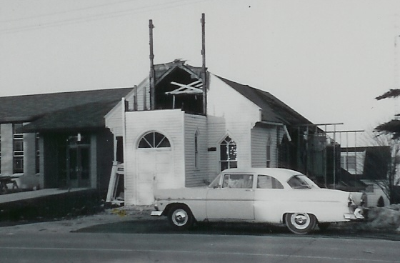

1959: Tearing down the old church.

Poinsettias

2018 Zion Christmas Poinsettias Given By:
Eunice Therrian | In memory and honor of loved ones
Donna B. Harju | In memory of Charles Harju
Dawn Akers | In memory of Carol Richel
Jacqueline Dell | In memory of Donald Dell
Ed Lester | In honor of Allen, Margaret & Jill Lester
Hilda & Jim Ryerse | In memory of our parents
The Feleppa Family | In memory of Linda & Mike Wilkins
Lynn Evans | In memory of James Morand
The Akers, Doran & Schlehuber families | In memory of Ramona Beeck Akers
Gary & Kathy Nickel | In memory of Ben & Ida Nickel and Dorothy Gamble
Stevan & Mary Christiansen | In honor of our families
Andrea Insley & Tina Schlehuber | In honor of Robert & Victoria Nelson
Monica & Gary Sorenson | In memory of Esther Sorenson, Stan Sorenson, Linda & Mike Wilkins and Jerry Fenlon
Betsy & Alan Turf | In memory of Marylee Eustis Smith and our parents

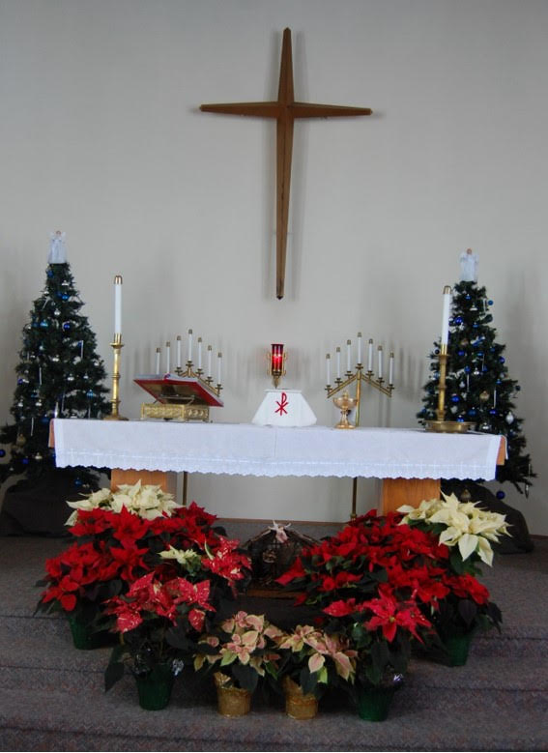

Christmas Eve 2018

We want to thank everyone who donated for the poinsettias and the evergreen crosses. The church looked beautiful!

Long-Term Care

Castle Rock Retirement Center:
Judy Ryerse

Evergreen Living Center:
Barb Lehto

Baptismal Anniversaries in January

Donna Harju 1
Barb Lehto 1
Kathy Marshall 1
Tonya Valletta 1
Aiden Stenson 3
Kaiden Stenson 3
Cole Christiansen 6
Molly Dandona 6
Jordan Grogan 6
Grace Wheeler 6
Lorraine Graham 7
Samantha Wyers 7
Nicole Coveyou 7
Brendan Insley 8
Tyler Snyder 9
Kyra Spencer 9
Helena St. Onge – Kissinger 9
Faith Gaubault 13
Lori Wilkins 27
Shirley Campbell 28
Bob Marshall 29

Birthdays in January

Tammy Shepard 1
Joshua St. Onge 5
Ellie Tielbar 6
Megan Stenson 7
Bev Kammers 8
Brian Harju 9
Judy Ryerse 11
Cliff Marshall 14
Danielle Paul 14
Lindsey Blair 16
Madeline Winberg 16
Ryan Idalski 18
Brendan Insley 18
Justin Therrian 18
Ryan Marshall 19
Becky Paul 20
Wade Marshall 21
Amy Dodds 22
Patric Schlehuber 23
Eric Elmblad 25
Micah Gaubault 25
Toni Johnston 25
Brenda St. Onge 26
Luke Valletta 26
Delores Marshall 28
Ryan LaVake 31

January Wedding Anniversaries

LaRoy & Marion Hill 22
Eldon & Shirley Winberg 23

Prayer List

(The prayer list is started new each year. If you would like someone added to the prayer list, please fill out a yellow card or call the church)

Mary Belonga, Dave & Lois Movalson, Barb Lehto, Bev Kammers, Eunice Therrian, Shirley Winberg, Judy Ryerse, Jim & Jerri Rose, Bill & Sandy Tielbar, Walter & Jane Puccio, Carol & John Watson, Larry Hopper, Donna Harju, Pastor Joe, Dorothy Pechta, Jack & Alfie Dyer, Ed Heenan, Lloyd & Marion Steiner, Levi Thompson, Zachary Baron, Odel, Pastor Shane Anderson, Kay Bahlman and the family and friends of Mike Wilkins.


Zion Funeral Committee January - March

Co-Leader: Betsy Turf (643-1512)
Co-Leader: Susan Fenlon (643-8730)

Trinity Worship Families

Jan 6 Kennedy Family
Jan 13 Rose Family
Jan 20 Movalson Family
Jan 27 Baron Family

Servants for Zion

Ushers & Greeters

Jan 6 Stevan & Mary Christiansen
Jan 13 Alan & Betsy Turf
Jan 20 Dena Barker & Lana Lennington
Jan 27 NOIZ

Lectors

Jan 6 Fred Feleppa
Jan 13 Richard Galor
Jan 20 Cathie Tielbar
Jan 27 Lynn Evans

Communion Assistants

Jan 6 Carol Elmblad
Jan 13 Steve Christianson
Jan 20 Dena Barker
Jan 27 Tammy Shepard

Acolytes

Jan 6 Gunnar Olsen
Jan 13 Josh Feleppa
Jan 20 Brendan Insley
Jan 27 Gunnar Olsen

Altar: Cathie Tielbar
Money Counters: Sandy & Emma Feleppa

The Usher duties are:
- Arrive 30 minutes before church
- Pass out bulletins and welcome guests
- Help with the offering and communion
- Record attendance

Usher list 2019

Jan 6 Stevan & Mary Christiansen
Jan 13 Alan & Betsy Turf
Jan 20 Dena Barker & Lana Lennington
Jan 27 NOIZ
Feb 3 Dave & Rita LaVake
Feb 10 Lorraine Graham & Lynn Evans
Feb 17 Stevan & Mary Christiansen
Feb 24 Cathie & Ellie Tielbar
Mar 3 Jon & Connie Olsen
Mar 10 Sunshine & Kennedy Kammers
Mar 17 Tim & Sally Idalski
Mar 24 Paul & Tammy Shepard
Mar 31 Merlin & Shannon Doran
Apr 7 Les & Debbie Therrian
Apr 14 Hilda Ryerse & Lynn Evans
Apr 21 Lorraine Graham & Martha Sjogren
Apr 28 Lana Lennington & Family
May 5 Bob Marshall & Faith Gaubault
May 12 Karen Schlehuber & Marialana Nygard
May 19 Nicole Garen Family
May 26 Stevan & Mary Christiansen
June 2 Cathie & Ellie Tielbar
June 9 Andrea Insley & Tina Schlehuber
June 16 Sandy & Fred Feleppa
June 23 Bob Marshall and Faith Gaubault
June 30 Paul & Tammy Shepard
July 7 Martha Sjogren & Lori Wilkins
July 14 Mark & Carol Elmblad
July 21 Lorraine Graham & Susan Fenlon
July 28 Delores & Cliff Marshall
Aug 4 Ray Wilkins & Richard Galor
Aug 11 Sandy & Fred Feleppa
Aug 18 Tim & Sally Idalski
Aug 25 Les & Debbie Therrian
Sep 1 Jon & Connie Olsen
Sep 8 Dave & Rita LaVake
Sep 15 Susan Fenlon & Lorraine Graham
Sep 22 Merlin & Shannon Doran
Sep 29 Alan & Betsy Turf
Oct 6 Karen Schlehuber & Marialana Nygard
Oct 13 Stevan & Mary Christiansen
Oct 20 Hilda Ryerse & Lynn Evans
Oct 27 Nicole Garen Family
Nov 3 Alan & Betsy Turf
Nov 10 Dena Barker & Lori Wilkins
Nov 17 NOIZ
Nov 24 Dena Barker & Lynn Evans
Dec 1 Ray Wilkins & Richard Galor
Dec 8 Mark & Carol Elmblad
Dec 15 Martha Sjogren & Lorraine Graham
Dec 22 Andrea Insley & Tina Schlehuber
Dec 24 Lana Lennington Family
Dec 29 Volunteers

Contact Information

Pastor David Tielbar may be reached at 906-984-2051 or at david.tielbar6@gmail.com. In an emergency, you can reach the Pastor’s cell phone at (563) 880-4512

Church telephone: 906-643-7870 - Answering machine
The secretary will usually be in the office on Tuesday and Thursday mornings from 9 – 12

The website is at http://zionstignace.com/home.html
- Find us on facebook at www.facebook.com/zionstignace

Email: ziontrinity950@gmail.com

Zion Evangelical Lutheran Church and Trinity Lutheran Church are congregations of the Northern Great Lakes Synod and the Evangelical Lutheran Church in America.

Trinity’s Sunday Service is at 9 a.m.
Zion’s Sunday Service is at 11 a.m.

Council Meetings

Joint Meeting –January 16, 2019 – 6:30 pm

Annual Meetings – January 27, 2019

Zion’s Council Members
President: Steve Christiansen 298-1051
Vice-President: Carol Elmblad 630-4380
Co-Treasurers: Dawn Akers 643-7552
Co-Treasurers: Lana Lennington 643-6576
Mary Christiansen 235-6123
Robert Marshall 643-8936
Secretary Dena Barker 430-1460
Emma Feleppa 430-8011
Tammy Shepard 906-984-2064

Trinity’s Council Members
President: Jerri Rose 292-5570
Vice-President Sharon Chalmers 292-5440
Secretary: Tracy Movalson 292-5581
Treasurer: Pega Kennedy 292-5633
Co-Treasurer: Jim Rose 292-5570
Financial Secretary: Tom Gustafson 292-5460
WELCA: Pega Kennedy 292-5633
John Kennedy 292-5633
Lois Movalson 292-5581
Treasurer's Report for Zion
January 1, 2018 through December 16, 2018
Income:
 | Amazon Smile Foundation | 35.98
 | Building | 85.00
 | Church Use Income | 1,235.00
 | General | 58,612.77
 | Fund Raising | 911.00
 | Memorial Fund | 1,200.00
 | Trinity Share | 12,629.85
 | TOTAL |  | 74,709.60
Expenses:
 | Administration | 5,707.26
 | Benevolence | 284.20
 | Church Maintenance | 12,837.51
 | Education | 771.05
 | Parsonage Maintenance | 3,673.31
 | Pastoral | 49,009.86
 | Worship | 2,943.29
 | --To Building Fund | 40.00
 |  |  | 75,266.48
 |  | Net Income | -556.88
***********************************************************
Thrivent Financial Investment Fund |  |  | 319.56
General fund balance: |  |  | 575.80
Kitchen/Building Fund balance |  |  | 1721.52
General fund owes building fund: |  |  | $ 45.00
General fund owes Mission Endowment fund: |  |  | $ 12,995.00

